**WE ARE LOOKING FOR CREATIVE PEOPLE!**

* Teachers, Instructors, Mentors - volunteer and share your drawing, painting, and dance experience with local children ages 7-12 who are eager to learn!
* Make a difference and impact on your community!
* All supplies provided! 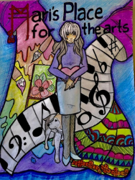

**Summer & Fall 2023 and Winter 2024**

Days: Tuesday/Wednesday/Thursday

Time: 4-5 pm and 5-6 pm

Locations: **Mari’s Place for the arts**

2321 Hoyt Avenue, Everett, WA 98201

**Lake Stevens Senior Center**

2302 Soper Hill Road, Lake Stevens, WA 98258

*To apply please email your resume to:* [*info@marisplaceforthearts.org*](mailto:info@marisplaceforthearts.org)

*The mission of Mari’s Place for the arts is to foster creativity and self-confidence in children and teens through arts and culture programs.*